Drag on Bluff and Streamlined Bodies

Laboratory Experiment  
ME 608 Fluid Dynamics, Fall 2018

*TECHNICAL REPORT   
December 2018*

Name of Group Members

Charlie Nitschelm  
Author One, [cjn1012@wildcats.unh.edu](mailto:cjn1012@wildcats.unh.edu)

Ross Thyne  
Author Two, rdt1002@wildcats.unh.edu

Lab Section: 3

Lab Time: Tues, 12/4, 3:10-4:30 (3)

|  |  |
| --- | --- |
| *Department of Mechanical Engineering*  *University of New Hampshire*  *Professor M. Wosnik*  *Teaching Assistants:*  *J. Cuevas Bautista, C. Boahmah-Mensah* | Image result for UNH logo |

Table of Contents

List of Figures ii

List of Tables ii

Abstract 1

Introduction and Background 2

Theory 2

Experimental Setup 2

Discussion of Results 3

Summary and Conclusion 5

References 6

# List of Figures

Figure 1. Drag Force, $FD$ [N], vs Reynolds number, $ReD$, for circular and square cylinders and NACA 0020 airfoil. 4

Figure 2. Drag coefficient, $cD$, vs Reynolds number, $ReD$, for circular and square cylinders and NACA 0020 airfoil, with comparison to values from literature. 5

Figure 3. Drag coefficient, $cD$, vs angle of attack, $α$, for three different Reynolds numbers for NACA 0020. 5

# List of Tables

Table 1: Significant dimensions of the test shapes 2

Table 2: Blockage ratio of each shape 2

Table 3: Density and viscocity of the flow fluid with temperature 3

(To insert new Figures or Tables in text of report , go to where you would like to insert them and use “References”, “Insert Caption…” )

# Abstract

A drag analysis on three separate objects were conducted at the University of New Hampshire’s wind tunnel located in Kingsbury Hall. The three objects, which were a square cylinder, a sphere cylinder and a NACO 0020 airfoil, were constrained inside the test section of the wind tunnel. A pressure differential was applied to the wind tunnel to begin airflow across each of these objects in the test section so measurements could be recorded to determine which shapes were most effective to limit the drag force applied to the object. The NACO 0020 airfoil was the most effective to limit drag, with the circular cylinder and square cylinder following it, respectively. Tests were also conducted on the square cylinder by adding tape to the top and bottom of the cross section impeding the flow to determine how it would affect its drag characteristics.

# Introduction and Background

Fluid dynamic drag rose in popularity during the dawn of the 20th century as humans began to jump off the earth with the invention of the first aeroplane. Since then, the field of fluid dynamic drag has been crucial to all dynamic inventions since. The interactions between fluid particles and rigid bodies continue to be studies to obtain a better understanding on how these objects behave in flight on Earth with an atmosphere. These studies have helped us create shapes that best suit the application intended to be performed in, whether it be to maximize or minimze its drag against its intended motion.

These applications can be understood from a casual trip on a commercial airplane. During takeoff, we seek to reach a speed in order to maximize its lift force to rise off the ground, and during landing, we seek to maximize drag to slow down the airplane to a safe landing speed once again. Drag impedes objects motion by stealing momentum from the body and transferring it to the molecules it encounters. This exchange of momentum and the factors in its magnitude is what we will investigate in this report.

# Theory

When any body is immersed ina fluid, whether that be water or air, fluid dynamic drag reduces to a surface force, meaning it is created and acts on the body’s surface area. These forces imparted on the object are completely dependent on the properties of the body and the fluid it is encountering. It does not matter if the body is moving through a static fluid, or a fluid is rushing past a static body, the drag it experiences is completely dependent on the relative speed of the body and the fluid. These are referred to as mobile fluid dynamic drag and static fluid dynamic drag, respectively.

A flow field helps us understand fluid motion more directly. To calculate a flow field, we must understand the velocity of the encountering flow at various points around the onject immersed. Normal and tangential stresses can be used to calculate the flows and flow gradients over the immersed body’s surface from the following equation:

$${\overset{⃑}{F}}_{res}= \iint_{CS}^{ }{\overset{⃑}{t} dS }= \iint_{CS}^{ }{\overset{⃑}{n}∙\overset{̿}{T} dS }$$

With dimensional analysis, groups from non-dimensional quantitative values can be collected through the experiment which can then be implemented in modeling as similar shapes often have close drag coefficients in correlation with the Reynolds Number,

(2)

$$Re= \frac{ρVl}{μ}$$

where $ρ$ is the density of the fluid, $V$ is the velocity of the fluid in relation to the object, $l$ is the characteristic length, which is the chord width of an airfoil, and $μ$ is the dynamic viscocity of the fluid. Buckingham Pi Theroem allows us to view the drag force and the coefficient of drag in terms of the Reynolds Number of the experiment setup. The equation below, which relates the force of drag, $F_{D}$, with the Reynolds number, is used to understand how the coefficient of drag related to its reynolds number.

(3)

$$\frac{F_{D}/L}{DρU_{c}^{2}}= φ(\frac{ρU_{c}L_{c}}{μ})$$

$$c_{D}=f(Re)$$

# Experimental Setup

The experimental wind tunnel in Kingsbury Hall at the University of New Hampshire is an labortory design, Model 404B. It is an open circuit-eiffel arrangement which has an operating flow speed range of $3 m/s$ to $46 m/s$. The 3 objects tested, which have fundamentally different shapes, are characterized in the table below detailing the shape parameters and its material.

Table 1: Significant dimensions of the test shapes

|  |  |  |  |  |
| --- | --- | --- | --- | --- |
| Shape | Material | Diameter (mm) | Length (mm) | Chord (mm) |
| Square Cylinder | Aluminum 6061 | 25.65 | 457.2 | N/A |
| Round Cylinder | Aluminum 6061 | 60.45 | 455.61 | N/A |
| Airfoil | Aluminum 6061 | 27.63 | 454 | 138.18 |

The ELD 440B wind tunnel is equipped with a 18” x 18” x 36” test section volume. Below is a table that details the blockage ratio or the flow-facing area of the body cross section to the cross section area of th test section.

Table : Blockage ratio of each shape

|  |  |
| --- | --- |
| Shape | Blockage (%) |
| Square Cylinder – Diameter | 5.60 |
| Round Cylinder – Diameter | 5.55 |
| Airfoil – Diameter | 6.06 |
| Airfoil – Chord | 6.00 |

There are three apparatuses that were implemented to help in measuring the physical quantities during the test. A force balance, pitot-static tube and manometers enabled us to make the calculations necessary to accuratly model its charateristics during the flow tests. The force balance allowed us to measure the force of drag on the body using a balance mounted in the wind tunnel test area. Each shape was mounted the same way to maintain consistency in setup. The manometers measured the gage pressure during the test which assisted in verifying the actual flow velocity by obtaining its data by being tangential to the flow. The pitot-static tube did the same calculation, but differed by directly facing the flow.

Physical measurements were also made outside of the test sections including the physical quantitues of the body, like length, diameter, and chord length with a suspected accuracy of 1 milimeter. Lastly, real-time fluid properties must be measured and recorded to ensure accuracy of data. The viscoity and air density of the fluid through the test section were measured with respect to its temperature as these properties are directly related to the measurements being taken.

During the test, we experienced a temperature increase of a few degrees celcius as the bodies and the devices performing the test send out a significant amount of thermal energy. These fluid properties through the time of the experiment were calculated by proven table depending on the temperature of the fluid.

Table : Density and viscocity of the flow fluid with temperature

|  |  |  |  |
| --- | --- | --- | --- |
| Kingsbury Hall S125 | Temperature [°C] | $ρ_{air}$ [ $kg/m^{3}]$ | $μ_{air}$ [ $Ns/m^{2}]$ |
| Beginning of Lab (15:24) | 24 | 1.188 | 1.832 ${10}^{-5}$* |
| Middle of Lab (15:54) | 24.9 | 1.184 | 1.836 ${10}^{-5}$* |
| End of Lab (16:24) | 25 | 1.183 | 1.837 ${10}^{-5}$* |

The experiment consisted of three different sections, initial measurements, installation/preperation, and operation/measurement. The last sections was done for each of the shapes tested discussed previously.

The measurment sections was completed by having students take intial measurements of each of the shapes as these will be important for post analysis. They were measured multiple times and averaged to obtain an accurate result.

The installation/preperation stage consisted of learning how to handle the ELD 404B wind tunnel. Each of the shapes were placed into the test section paying close attention to make sure the body was not touching the walls, leaving a small gap to make sure none of the drag force would be transferred into the wall, and not the force balance.

The operations/measurement stage happened multiple times to get the data from each of the shapes tested. The square body was tested first, oriented to have a flat face perpendicular to the flow. The round cylinder was tested next, making sure the fixture of the body was set up the same as the square. We then tested the NACA 0020 airfoil at a zero angle of attack with respect to the flow field. Once the three shapes were tested, we went back to the round cylinder shape and added strips of tape to the bottom and top of the cross section against the flow field, acting as a flow trip disrupting the laminar flow it experiences around it. During all these tests, values were recorded for drag force and manometer readings. The drag force readings were the instantaneous values read from the force balance, and the manomenter was read by eye from a resting fluid.

There were various soruces of error during the test that could affect our final calculations. All physical measurement of the objects are not perfect and are subject to human error of up to 1 milimeter. Our tests are also subject to error as the flow velocity rose to higher values, the bodies could collide with the wall, imparting some of the drag force into the wall, lowering the actual drag the body is encountering recorded from the force balance.

# Discussion of Results

At the beginning of the discussion of results, you might want to say something about the range of Reynolds numbers covered in the experiments. (maybe a table?) You could also use Fig 9.3 from your text book (circular cylinder) and show which range of Reynolds number we are covering… (copy & paste the graphic, add a citation/reference for the text book).

“The measured drag forces, $F_{D}$ [N], for the circular and square cylinders and the NACA 0020 airfoil at zero degree angle of attack (AoA=0°), plotted versus Reynolds number based on the cross-stream characteristic length, $Re_{D}$, are shown in Figure 1. “ (followed by discussion of results)   
(below is a sample figure – for which I removed the axis labels)

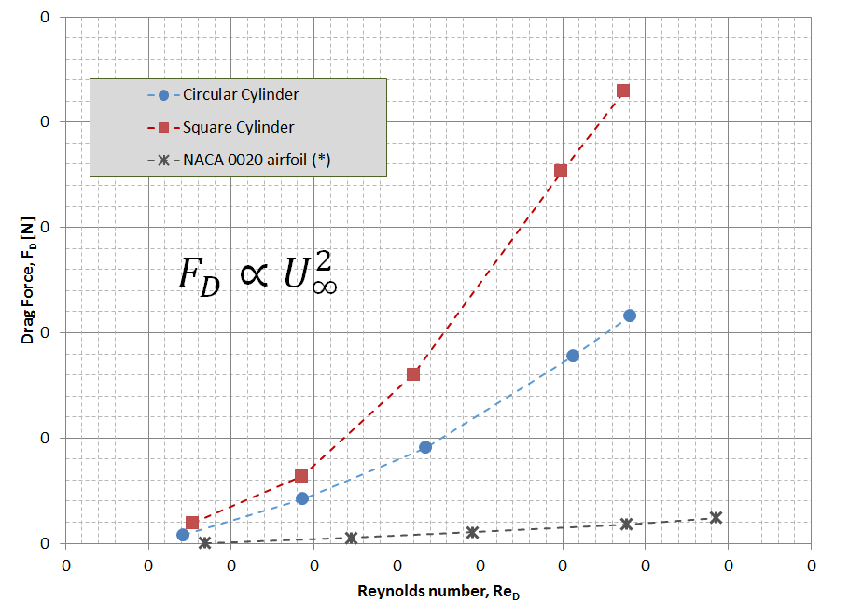

Figure 1. Drag Force, $F_{D}$ [N], vs Reynolds number, $Re_{D}$, for circular and square cylinders and NACA 0020 airfoil.

“The drag coefficients, $c_{D}$, for the circular and square cylinders and the NACA 0020 airfoil at zero degree angle of attack (AoA=0°), plotted versus Reynolds number based on the cross-stream characteristic length, $Re_{D}$, are shown in Figure 2. Also plotted in this figures are data from literature: For the circular and square cylinders values from Hoerner (1967) [2] are plotted as $c_{D,circular}=1.17$ and $c_{D,square}=2.05$, respectively. Data for a slightly thicker symmetrical airfoil, the NACA 0021, from Sheldahl and Klimas (1981) [3] are plotted for zero angle of attack, converted from Reynolds number based on chord to Reynolds number based on foil thickness to facilitate comparison with the other shapes.”

(Note: airfoil data is given based on planform area (=span x chord). So for the airfoil data, you need to multiply Re_c by 0.21, and divide c_D by 0.21, to get c_D and Re data based on foil thickness)

(again, followed by discussion of results)

(figure here)

Figure 2. Drag coefficient, $c_{D}$, vs Reynolds number, $Re_{D}$, for circular and square cylinders and NACA 0020 airfoil, with comparison to values from literature.

The drag coefficients, $c_{D}$, for the NACA 0020 airfoil at different angle of attack, AoA=0°, 8°, 16°, are plotted below. Also compare to existing data.

2 ways to plot this:

* As before, plot $c_{D}$ versus Reynolds number – note that you should be using the Reynolds number based on chord when plotting airfoil data by itself
* Or, since we essentially have data for different angle sof attack at 3 (nominal) Reynolds numbers, you can plot $c_{D}$ versus angle of attack. This is how this data is typically presented, since this plot illustrates the effect of flow separation at higher angles of attack better.

(again, followed by discussion of results)

(figure here)

Figure 3. Drag coefficient, $c_{D}$, vs angle of attack, $α$, for three different Reynolds numbers for NACA 0020.

# Summary and Conclusion

Participating in a hands-on lab was crucial to our development to understand flow around an object when immersed in it. We calcuated the actual relations between Reynolds Number, drag forces and it respective coefficient of drag. It allowed us to practice our skills in measuring, installing and operating the wind tunnel. The recordings from the experiment then enabled us to analyze and these relationships to get a better undersanding of the complex field of fluid dynamics on moving bodies immersed in a fluid.

In conclusion, the wind tunnel allowed us to determine the basic properties of the drag on different objects. With respect to its drag force and drag coefficients, the NACA 0020 airfoil displaces the smallest values, which agrees with what we suspected as they are used on airplanes. The circular cylinder has the second smallest drag values, and then the square. When tape was added to the circular cylinder during our last test, the object experiences more drag during the low flow speeds, but then decreased compared to the object without tape, showing the phenomenon of how the fluid behaves at higher mach numbers, preferring sharper objects against the flow, and allowing the flow to attach to the object for longer before slpitting off of it, seperating.

# References

|  |  |
| --- | --- |
| [1] | P. J. Pritchard, Fox and McDonald’s Introduction to Fluid Mechanics, 8th edition, John Wiley & Sons, Inc., 2011. |
| [2] | S. F. Hoerner, Fluid-Dynamic Drag: practical information on aerodynamic drag and hydrodynamic resistance, Hoerner Fluid Dynamics, 1965. |
| [3] | R. E. Sheldahl and P. C. Klimas, "Aerodynamic Characteristics of Seven Symmetrical Airfoil Sections Through 180-Degree Angle of Attack for Use in Aerodynamics Analysis of Vertical Axis Wind Turbines. Report SAND80-2114.," Sandia National Laboratories, 1981. |